Faculty of Computing

SE2030 – Software Engineering

Year 2 Semester 1 (2025)

**Web-based E-channeling System**

Lab sheet 03

**Group ID:** 2025-Y2-S1-MLB-B6G1-10

**Batch Group No:** Y2.S1.WD.IT.6.01

|  |  |
| --- | --- |
| **Student ID** | **Name** |
| IT24101291 | Vidya .R |
| IT24101397 | Wickramasinghe W.A.P.J.S.D |
| IT24101347 | Madushanka E D |
| IT24101466 | Akeeth W K A |
| IT24101461 | Hannadige A. K. L. F. |
| IT24103547 | Oshadi J.A.A. |

20.08.2025

**Use Case Diagram**

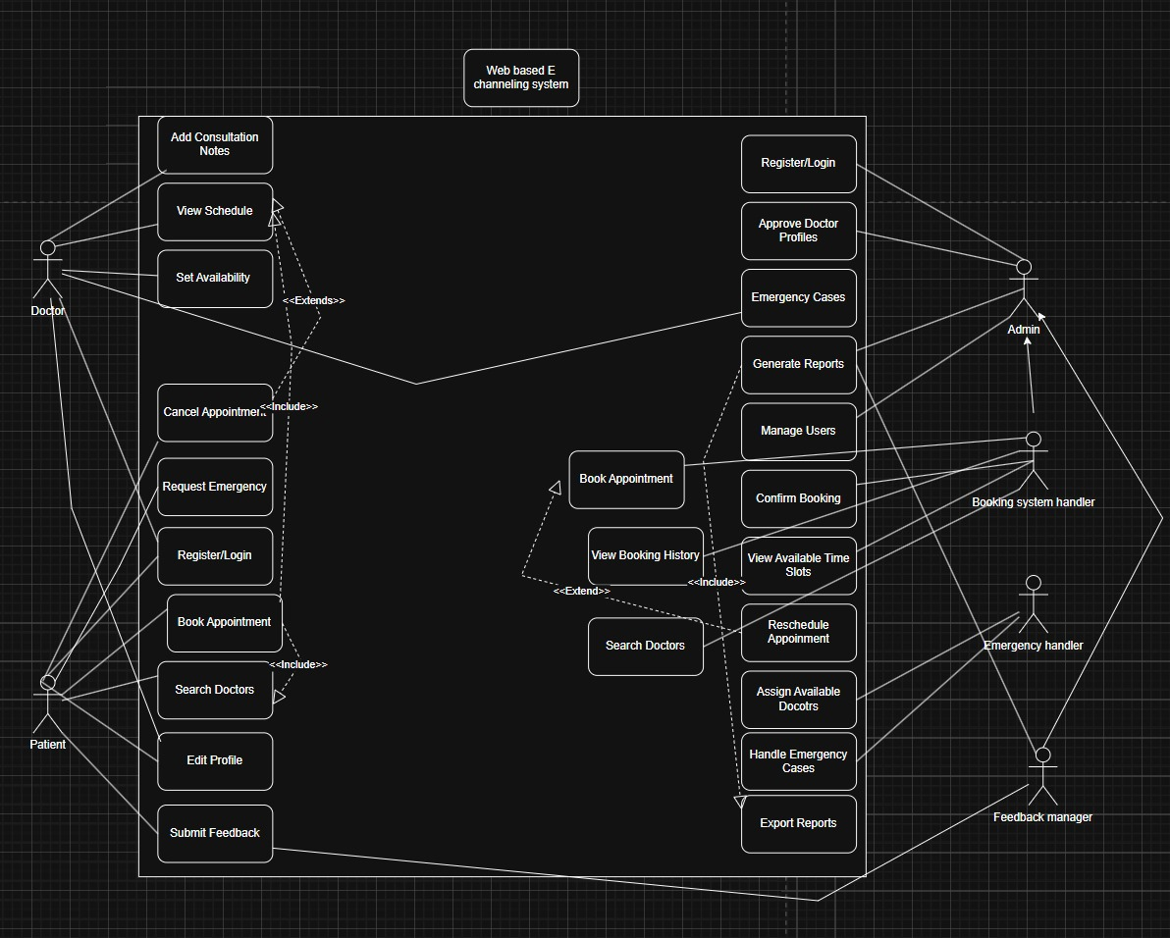

**Use Case Scenarios**

1. **Patient Portal & Dashboard – Akeeth W K A**

In this use case, the patient, after registering with the system, logs in to access the patient portal and dashboard. The system immediately displays both upcoming and past appointments, giving the patient a complete overview of their medical interactions. From this dashboard, the patient can book new appointments with doctors, as well as reschedule or cancel existing ones depending on their needs. In situations requiring urgent attention, the patient can request an emergency appointment directly through the portal. Once a consultation is completed, the system also allows the patient to submit feedback, ensuring that they remain actively engaged in improving the quality of healthcare services. As a result, the patient able to manage all appointments and personal interactions smoothly in one unified interface.

* **Use Case:** Manage Appointments
* **Actor:** Patient
* **Precondition:** Patient must be registered and logged in.
* **Main Flow:**
* Patient logs in to system.
* System shows upcoming and past appointments.
* Patient can book, reschedule, or cancel an appointment.
* Patient can request an emergency appointment.
* Patient submits feedback after consultation.
* **Outcome:** Patient manages personal appointments and interactions smoothly.

1. **Doctor Portal & Dashboard – Vidya R.**

This use case describes how doctors interact with the system to manage their availability and appointments. After logging in with their approved account, the doctor is presented with a portal that allows them to add or update their available time slots. This availability information is then updated in real time so that patients can view it when booking consultations. The doctor also has access to their schedule, which shows upcoming appointments in detail. If necessary, the doctor can add consultation notes or issue prescriptions for patients through the system. Through this portal, doctors able to efficiently manage their schedules, keep track of bookings, and provide better continuity of care.

* **Use Case:** Manage Availability & Schedule
* **Actor:** Doctor
* **Precondition:** Doctor must have an approved account.
* **Main Flow:**
* Doctor logs in to system.
* Doctor sets or updates available time slots.
* System updates availability for patients to view.
* Doctor views booked appointments.
* Doctor optionally adds consultation notes/prescriptions.
* **Outcome:** Doctor efficiently manages patient schedule.

1. **Admin Panel – Wickramasinghe W.A.P.J.S.D**

This use case, the administrator manages doctor profiles to ensure the integrity of the system. Once authenticated and logged in, the admin can access the panel where pending doctor registration requests are displayed. The administrator carefully reviews each request, examining the details provided by the applicants. After evaluation, the admin either approves or rejects the doctor’s profile depending on compliance with system requirements. The rejected profiles will deleted by admin.Once a decision is made, the system updates the profile status and notifies the doctor of the outcome. This ensures that only verified doctors are granted access, thereby maintaining security and reliability across the platform.

* **Use Case:** Manage Doctor Profiles
* **Actor:** Admin
* **Precondition:** Admin is authenticated.
* **Main Flow:**
* Admin logs in.
* System displays pending doctor registration requests.
* Admin reviews submitted details.
* Admin approves or rejects profile.
* Admin deletes rejects profiles.
* System updates status and notifies doctor.
* **Outcome:** Only verified doctors gain system access.

1. **Patient Booking System – Hannadige A. K. L. F**

This use case focuses on the patient’s interaction with the booking system to secure an appointment. After logging into the platform, the patient searches for doctors using filters such as specialization, hospital, or preferred date. The system processes the search and displays a list of available doctors along with their time slots. The patient then selects a convenient time slot and confirms the booking. Following confirmation, the system generates a booking record with details that the patient can access at any time. This process ensures that patients can quickly and conveniently find the right doctor and book appointments without delay.

* **Use Case:** Book Appointment
* **Actor:** Booking System Handler
* **Precondition:** Patient is logged in.
* **Main Flow:**
* Patient searches for doctor (filters by specialization, hospital, date).
* System displays available doctors and time slots.
* Patient selects slot and confirms booking.
* System generates booking confirmation.
* **Outcome:** Patient successfully books appointment.

1. **Emergency Appointment Management – Oshadi J.A.A.**

In this scenario, the system handles urgent medical needs through the emergency appointment module. A registered patient begins by filling out an emergency booking form with symptoms. Once submitted, the system automatically routes the request to available doctors. Both admins and doctors acting as emergency handlers receive an instant emergency alert, enabling rapid response. The doctor then reviews the request and confirms availability to take the case. Once confirmation is given, the emergency appointment is scheduled immediately, ensuring the patient receives prompt medical attention. This user case demonstrates how the system prioritizes and addresses critical medical cases efficiently.

* **Use Case:** Handle Emergency Request
* **Actor:** Emergency Handler
* **Precondition:** Patient is registered.
* **Main Flow:**
* Patient fills emergency booking form with symptoms.
* System routes request to available doctor.
* Admin/Doctor gets emergency alert.
* Doctor confirms availability.
* Emergency appointment scheduled.
* **Outcome:** Urgent cases handled quickly.

1. **Feedback & Reporting Management – Madushanka E D**

This use case explains how feedback and reporting are managed within the system. After completing a consultation, the patient able to submit ratings and comments about their experience. These feedback entries become available for doctors to review, helping them to identify areas for improvement in their services. Administrators, acting as feedback managers, can further review and filter the feedback collected, generating reports to analyze overall service quality and trends. These reports can also be exported for record-keeping and decision-making purposes. Ultimately, the feedback and reporting system contributes to continuous improvement in healthcare delivery and supports better management decisions.

* **Use Case:** Submit Feedback & Generate Reports
* **Actor:** Feedback system manager
* **Precondition:** Appointment completed.
* **Main Flow**:
* Patient submits rating and feedback.
* Doctor views feedback for improvements.
* Admin reviews, filters, and exports reports.
* Reports stored for performance analysis.
* **Outcome:** Feedback improves quality and reporting supports monitoring.